



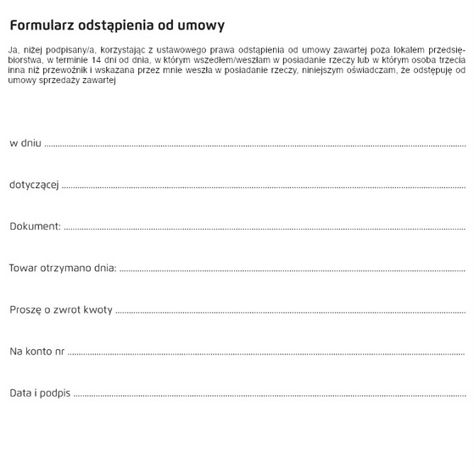

Dream Houses sp.j.  
Ptasia 20 B/1

60-319 Poznań